**PIZZA SALES SQL QUERIES**

1. **KPI’s**
2. Total Revenue:

Select Sum(total_price) As TOTAL_REVENUE From pizza_sales ;

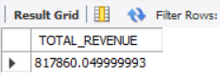

2.Average Order Value

Select Sum(total_price) / Count(distinct order_id) As Avg_Order_Value From pizza_sales ;

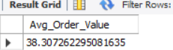

3.Total Pizza Sold

Select Sum(quantity) As Total_Pizza_Sold From pizza_sales ;

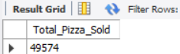

4.Total Orders

Select Count(distinct order_id) As Total_Orders From pizza_sales;

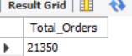

5.Average PizzAs

Select Sum(quantity) / Count(distinct order_id) As Avg_PizzAs From pizza_sales ;

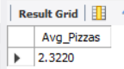

1. **Daily Trend for Total Orders**

Select dayname(order_date) As order_day, Count(distinct order_id) As Total_Orders From pizza_sales

group by dayname(order_date);

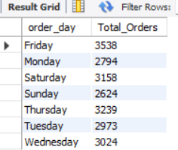

**C. Monthly Trend for Orders**

Select monthname(order_date) As month_name, Count(distinct order_id) As Total_Orders From pizza_sales

group by monthname(order_date)

order by Total_orders desc;

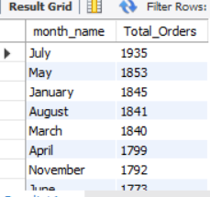

**D. % of Sales by Pizza Category**

SELECT

pizza_category,

Sum(total_price) As Total_Sales,

( SUM(total_price) * 100 / (SELECT SUM(total_price) FROM pizza_sales where month(order_date) = 1)) As Percentage

FROM

pizza_sales

where month(order_date) = 1

GROUP BY

pizza_category;

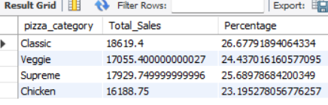

**E. % of Sales by Pizza Size**

SELECT

pizza_size,

Sum(total_price) As Total_Sales,

cAst( SUM(total_price) * 100 / (SELECT SUM(total_price) FROM pizza_sales ) As decimal (10,2)) AS Percentage

FROM

pizza_sales

GROUP BY

pizza_size

order by

Percentage Desc ;

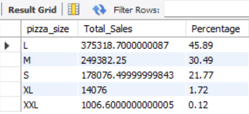

**F. Total PizzAs Sold by Pizza Category**

Select pizza_name , Sum(total_price) As Total_Revenue From pizza_sales

group by pizza_name

order by Total_Revenue desc

limit 5;

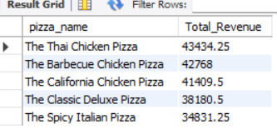

**G. Top 5 PizzAs by Revenue**

Select pizza_name , Sum(quantity) As Total_Quantity From pizza_sales

group by pizza_name

order by Total_Quantity desc

limit 5;

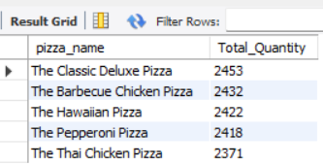

***NOTE***

If you want to apply the pizza_category or pizza_size filters to the above queries you can use WHERE clause. Follow some of below examples

SELECT Top 5 pizza_name, COUNT(DISTINCT order_id) AS Total_Orders

FROM pizza_sales

WHERE pizza_category = 'Classic'

GROUP BY pizza_name

ORDER BY Total_Orders ASC